**DAILY ONLINE ACTIVITIES SUMMARY**

|  |  |  |  |  |  |  |  |  |
| --- | --- | --- | --- | --- | --- | --- | --- | --- |
| **Date:** | **1/06/2020** | | | | | **Name:** | **SPOORTI S DAROJI** | |
| **Sem & Sec** | **4th SEM. & ‘B’ SEC.** | | | | | **USN:** | **4AL18CS088** | |
| **Online Test Summary** | | | | | | | | |
| **Subject** | | **COMPLEX ANALYSIS,PROBABILITY AND STATISTICAL METHODS** | | | | | | |
| **Max. Marks** | | **30** | | **Score** | | | **28** | |
| **Certification Course Summary** | | | | | | | | |
| **Course** | **Intro to Django for Web development** | | | | | | | |
| **Certificate Provider** | | | **Udemy** | | **Duration** | | | **3 Hrs.** |
| **Coding Challenges** | | | | | | | | |
| **Problem Statement 1: Given an array arr[] of size N and an integer K. The task is to find the count of subarrays such that each subarray has exactly K distinct elements.**  **Problem Statement 2: Define a class Point with two fields x and y each of type double. Also , define a method distance(Point p1, Point p2) to calculate the distance between points p1 and p2 and return the value in double.. Use Math.sqrt( ) to calculate the square root.** | | | | | | | | |
| **Status: Executed.** | | | | | | | | |
| **Uploaded the report in Github** | | | | | **Yes** | | | |
| **If yes Repository name** | | | | | [alvas-education-foundation](https://github.com/alvas-education-foundation)/[spoorti_daroji](https://github.com/alvas-education-foundation/spoorti_daroji) [spoorti_daroji](https://github.com/alvas-education-foundation/spoorti_daroji)/coding_solutions/ | | | |
| **Uploaded the report in slack** | | | | | **Yes** | | | |

**Online Test Summary:**

**The 18MAT41 test was scheduled from 9:25AM to 10:10AM.The Portion for the IA was the 3rd module. There were 10 questions of one mark & 10 questions of 2 marks the time assigned was 40 minutes. The questions were mcq type.**

**Online Certification course Summary:**

**In today’s session I learnt about the Introduction Django**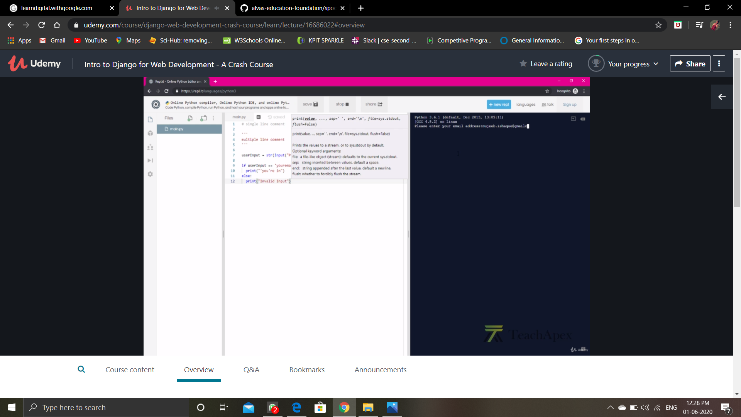

**Online Coding Summary: Today I received the program from prof.Shilpa Hassan CSE Dept and prof.Vasudev CSE Dept ,prof.Venkatesh CSE Dept.**

**The program is mentioned above in the coding challenges.I have written a program and uploaded it to my Github repository, as shown in the below.**

